**MBAN 6120 Assignment 1**

**Chapter 3 Level I and II Exercises**

1 a) b)

/********************************************************************/

/* This program uses an INFILE statement to read a raw data file. */

/* The INFILE statement includes a full path for Microsoft Windows. */

/* */

/* For UNIX or SAS onDemand: */

/* Replace the INFILE statement with the following statement: */

/* infile "&path/donation.dat"; */

/* */

/* For z/OS: */

/* Replace the INFILE statement with the following statement: */

/* infile "&path..rawdata(donation)"; */

/********************************************************************/

**data** work.donations;

infile "&path\donation.dat";

input Employee_ID Qtr1 Qtr2 Qtr3 Qtr4;

Total=sum(Qtr1,Qtr2,Qtr3,Qtr4);

**run**;

**proc** **contents** data=work.donations;

**run**;

**proc** **print** data=work.donations;

**run**;

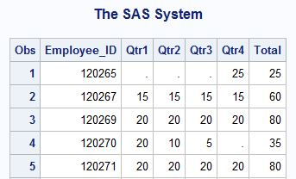

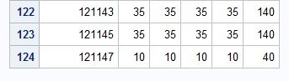

2 a) b)

**data** work.newpacks;

input Supplier_Name $ **1**-**20** Supplier_Country $ **23**-**24**

Product_Name $ **28**-**70**;

datalines;

Top Sports DK Black/Black

Top Sports DK X-Large Bottlegreen/Black

Top Sports DK Comanche Women's 6000 Q Backpack. Bark

Miller Trading Inc US Expedition Camp Duffle Medium Backpack

Toto Outdoor Gear AU Feelgood 55-75 Litre Black Women's Backpack

Toto Outdoor Gear AU Jaguar 50-75 Liter Blue Women's Backpack

Top Sports DK Medium Black/Bark Backpack

Top Sports DK Medium Gold Black/Gold Backpack

Top Sports DK Medium Olive Olive/Black Backpack

Toto Outdoor Gear AU Trekker 65 Royal Men's Backpack

Top Sports DK Victor Grey/Olive Women's Backpack

Luna sastreria S.A. ES Hammock Sports Bag

Miller Trading Inc US Sioux Men's Backpack 26 Litre.

;

**run**;

**proc** **contents** data=work.newpacks;

**run**;

2 c) 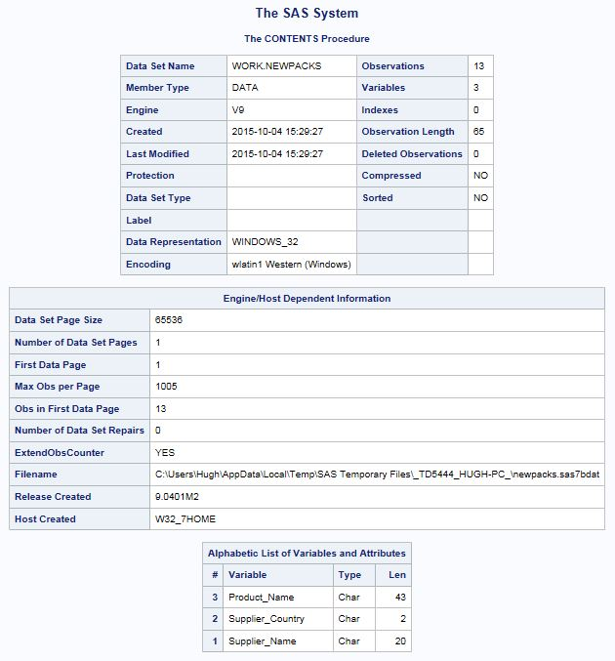

There are 13 observations in the data set.

There are 3 variables in the data set.

The length of the variable Product_Name is 43 bytes

2 d) **proc** **print** data=work.newpacks;

**run**;

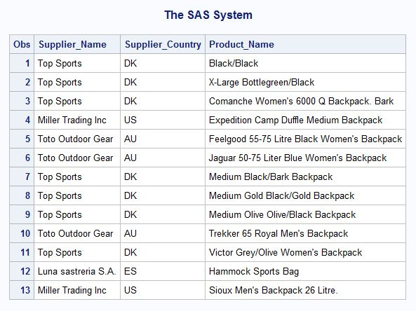

4 a)

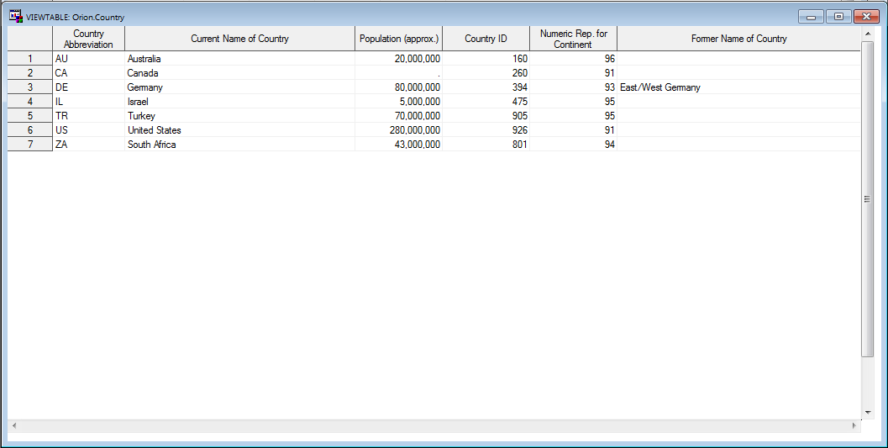

There are 7 observations in the **orion.country** data set

There are 6 variables in the **orion.country** data set

The name of the last country in the data set is **South Africa**

4 b) **proc** **contents** data=orion._all_ nods;

**run**;

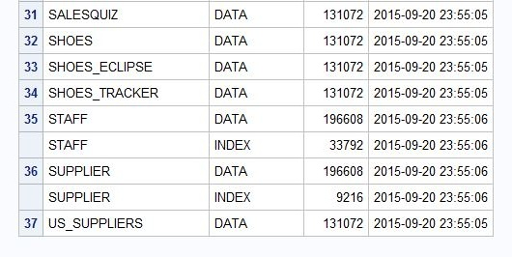

The name of the last member listed is **US_SUPPLIERS**

5 a) **proc** **contents** data=orion.staff;

**run**;

The information from the contents procedure tells us the following information:

* The data set has 424 observations, 10 variables, 2 indices and 1 integrity constraint
* The data set was created and last modified on Sept 20, 2015
* The primary key _PK0001_, which has variables Employee_ID and Start_Date, is the integrity constraint
* The Indices are Employee_ID and _PK0001_

**Chapter 4 Level I and II Exercises**

1 a) 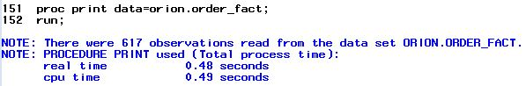

b)

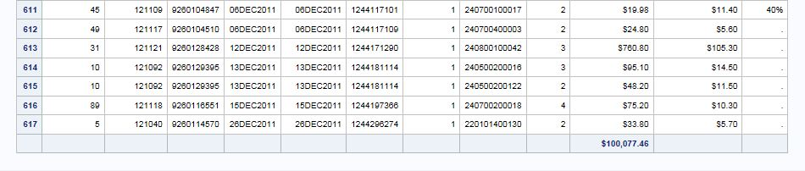

c) 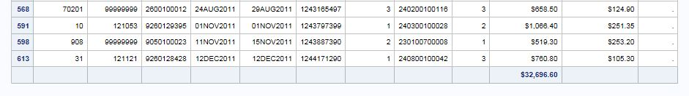

Note that the numbers are not sequential. The original observation numbers are displayed.

The sum of **Total_Retail_Price** changed to reflect only the subset

d) To verify thenumber of observations in the results with the Obs column suppressed,

simply check the log.

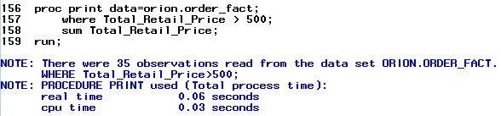

1 e) When the ID statement is added, Customer_ID becomes the leftmost column and is displayed on each line of the observation.

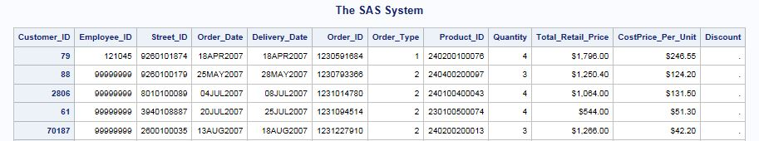

f) When the VAR statement is added there are two Customer_ID columns. The first column is the ID field, and the second one is included because Customer_ID is listed in the VAR statement.

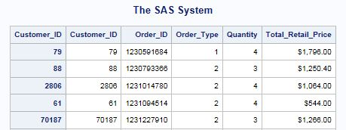

g)

**proc** **print** data=orion.order_fact noobs;

where Total_Retail_Price > **500**;

id Customer_ID;

var Order_ID Order_Type Quantity Total_Retail_Price;

sum Total_Retail_Price;

**run**;

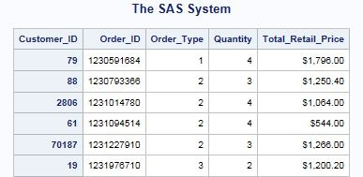

2 a)

**proc** **print** data=orion.customer_dim;

**run**;

b)

**proc** **print** data=orion.customer_dim noobs;

where Customer_Age between **30** and **40**;

**run**;

c)

**proc** **print** data=orion.customer_dim noobs;

where Customer_Age between **30** and **40**;

id Customer_ID;

**run**;

d)

**proc** **print** data=orion.customer_dim noobs;

where Customer_Age between **30** and **40**;

id Customer_ID;

var Customer_Name Customer_Age Customer_Type;

**run**;

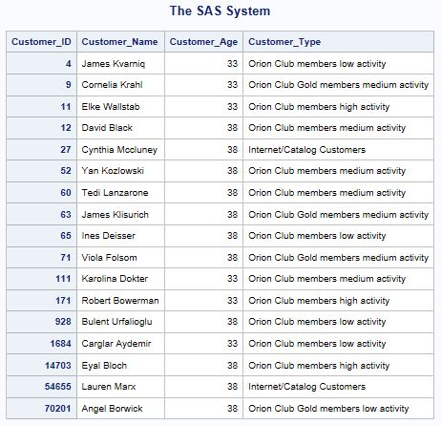

5 a) b)

**proc** **sort** data=orion.employee_payroll out=work.sort_salary;

by salary;

**run**;

**proc** **print** data=work.sort_salary;

**run**;

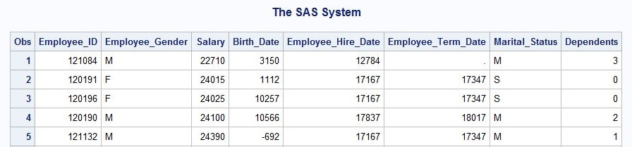



6 a) b)

**proc** **sort** data=orion.employee_payroll out=work.sort_salary2;

by Employee_Gender descending Salary;

**run**;

**proc** **print** data=work.sort_salary2;

by Employee_Gender;

**run**;

**quit**;

6 b)

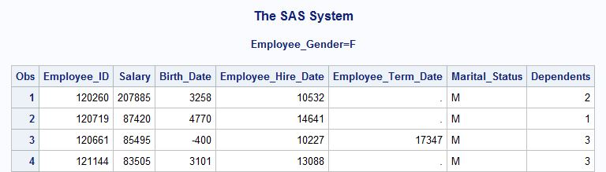

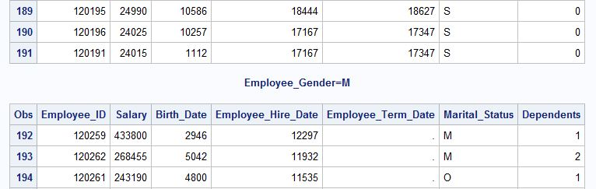

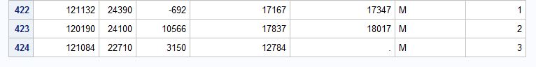

7 a)

**proc** **sort** data=orion.employee_payroll out=work.sort_sal;

by Employee_Gender descending Salary;

**run**;

b)

**proc** **print** data=work.sort_sal noobs;

by Employee_Gender;

sum Salary;

where Employee_Term_Date is missing and Salary > **65000**;

var Employee_ID Salary Marital_Status;

**run**;

7 b)

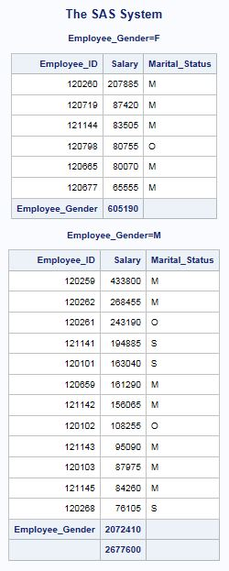

9 a)

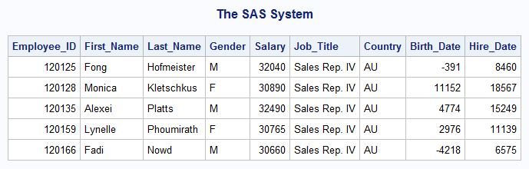

9 b) c) d) e)

title1 'Australian Sales Employees';

title2 'Senior Sales Representatives';

footnote1 'Job_Title: Sales Rep. IV';

**proc** **print** data=orion.sales noobs;

where Country='AU' and Job_Title contains 'Rep. IV';

var Employee_ID First_Name Last_Name Gender Salary;

**run**;

title;

footnote;

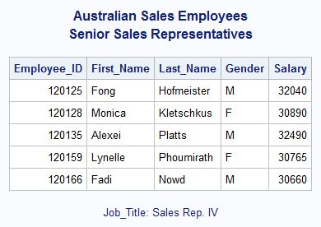

10 a)